**Name**- Dr. Tukaram D. Urmode

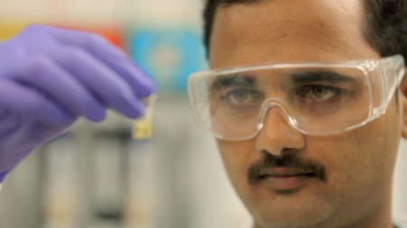**Photo**-

**Education**- M. Sc, Ph. D (Organic chemistry)

**Email**- [tdu.u4u@gmail.com](mailto:tdu.u4u@gmail.com)

**Ph. D thesis title**- “Synthetic Studies towards Derivatives of Prenostodione, Nostodione A, Carbolines, Azacarbolines and High Energy Materials - TNAD and CL-20”

**Duration of thesis work**- 26/8/2015 to 1/6/2018

**Current Position**- Assistant Manager (R&D)

**Company Name**- Fujifilm Sericol India Private Limited

10/11,B.U. Bhandari Industrial Estate,

Sanaswadi, Tal.- Shirur, Dist - Pune 412208

**Publication**-

1. Synthesis of Spiroindolone scaffolds by Pictet-Spengler Spirocyclisation using β-cyclodextrin-SO3H as a recyclable catalyst.

Tukaram D. Urmode, Monali A. Dawange, Vaishali S. Shinde and Radhika S. Kusurkar

*Tetrahedron*, **2017**, *73*, 4348-4354.

2. Short synthesis of carbazole alkaloids: Ekeberginine, murrayaquinone A, and glycozoline

Aadil A. Momin, Tukaram D. Urmode, Shrikar M. Bhosale, and Radhika S. Kusurkar

*Syn comm*, **2016**, *46* (*15*), 1292–1298.

3. Acid Catalyzed Synthesis of Spiroindolone Scaffolds by Iso-Pictet-Spengler Spirocyclisation and Evaluation of their Antibacterial Activity

Monali A. Dawange, Tukaram D. Urmode, Ayesha Khan, and Radhika S. Kusurkar

*ChemistrySelect* **2017**, *2*, 2552-2555.

4. Differential response of antioxidant defense in HepG2 cells on exposure of Livotrit, in a concentration dependent manner

Sajad Malik, Swati Khole, Smriti Mittal, Tukaram Urmode, Radhika Kusurkar, Saroj Ghaskadbi

[*J Tradit Complement Med.*](https://www.ncbi.nlm.nih.gov/pubmed/30671364) **2018**, *9* (*1*), 38-44.